A Review Paper on: “Digital Transformation and Cybersecurity in Healthcare: Balancing Innovation and Safety”
Dr Pushparani M K¹, Adithya², Nithin³, Santhosh⁴, Shreyas⁵
¹Associate Professor, Computer Science and Design, Alvas Institute of Engineering and Technology, Mijar, India
²Student, Computer Science and Design, Alvas Institute of Engineering and Technology, Mijar, India ³Student, Computer Science and Design, Alvas Institute of Engineering and Technology, Mijar, India
⁴Student, Computer Science and Design, Alvas Institute of Engineering and Technology, Mijar, India ⁵Student, Computer Science and Design, Alvas Institute of Engineering and Technology, Mijar, India
Emails: drpusparani@aiet.org.in¹, adithyashetty016@gmail.com², nithin7899822235@gmail.com³, santhoshgowda0804@gmail.com⁴, s30617699@gmail.com⁵
Abstract
The growing use of digital technologies in healthcare has led to major improvements in patient care, communication, and operational efficiency. However, it has also introduced significant cybersecurity challenges. Healthcare systems are increasingly targeted by threats such as data breaches, ransomware attacks, and vulnerabilities in connected medical devices. This paper reviews the current cybersecurity risks in healthcare and their potential impact on patient safety and data privacy. Notable incidents like the Anthem Blue Cross breach and the WannaCry ransomware attack are examined to highlight the real-world consequences of poor cybersecurity practices. The paper also discusses emerging technologies—such as AI, telehealth, cloud computing, and wearables—and their associated risks and benefits. Best practices for mitigating cybersecurity threats are presented, including regulatory compliance, data encryption, staff training, risk assessment, and incident response plan.

Keywords: Healthcare cybersecurity, Zero-Trust Model, medical IOT risks, Patient Data Protection

- INTRODUCTION
As healthcare organizations increasingly rely on digital technologies like Electronic Health Records (EHRs), connected medical devices, and cloud platforms, they have become prime targets for cyberattacks. While digital systems improve efficiency and patient care, they also create serious security risks. Patient data—including medical records, financial details, and personal identifiers—is highly valuable to cybercriminals, making healthcare a major target.
Cybersecurity is no longer just a technical issue; it's a matter of patient safety and organizational risk. The American Hospital Association urges hospital leaders to treat it as a strategic priority, integrating it into overall risk management and business continuity planning.
However, many healthcare organizations struggle with cybersecurity due to limited resources, outdated systems, and a shortage of skilled professionals. Complex IT systems, lack of staff training, and vulnerable IoT-connected medical devices further increase the risk. Ransomware attacks, in particular, can cripple operations and endanger lives, as providers often feel pressured to pay to restore access to vital systems.
As healthcare becomes more global, data sharing across borders and compliance with various privacy laws adds further complexity. Protecting patient data requires a proactive, collaborative approach involving updated technology, strong security practices, and cross-industry cooperation.
- ISSUES
Healthcare organizations are becoming major targets for cyberattacks because of their valuable data and increasing reliance on digital technologies like Electronic Health Records (EHRs), connected devices, and cloud systems. Health records can sell for up to 10 times more than credit card numbers on the dark web, and the cost of a data breach in healthcare is nearly three times higher than in other industries.
2.1 Outdated Security and the Shift to Zero Trust
Many organizations still use a perimeter-based security model, which focuses on keeping intruders out. However, as cyber threats grow more sophisticated, this method is no longer enough. A modern approach called Zero Trust is gaining traction. It assumes no user or system should be trusted by default, even if inside the network, and focuses on securing every part of the system individually.
2.2 Third-Party Risks and Real-World Examples
Healthcare systems are often compromised through third-party vendors with weak security. A well-known example is the Target data breach, where hackers accessed the system using credentials from a small HVAC vendor. They quietly tested malware before expanding the attack, eventually stealing 40 million credit and debit card records.
Another case is the Colonial Pipeline ransomware attack, where hackers used a stolen password to access business systems. Despite using secure tools like VPNs, simple user mistakes can still open the door to large-scale breaches. Similarly, the SolarWinds breach showed how hackers can compromise thousands of organizations by targeting one software provider used across industries.
2.3 Healthcare's Growing Cyber Risks
Healthcare organizations often lack the resources to defend against advanced threats. Older systems, untrained staff, and connected medical devices (IoT) with poor security create more vulnerabilities. Ransomware, where hackers lock systems and demand payment (usually in cryptocurrency), has become a common and costly threat.
2.4 More Interconnected Systems = More Vulnerabilities
As healthcare systems become more connected—with multiple partners, payment systems, and legal requirements—the number of entry points for attackers increases. International data sharing and inconsistent cybersecurity practices add further complexity. APIs (software connections between systems) are also frequently targeted by hackers.
2.5 Lessons from High-Profile Attacks
Public attacks, like the 2018 Atlanta ransomware attack, show the real-world costs. While hackers demanded $51,000 in Bitcoin, the city spent over $17 million to recover. Paying ransoms doesn’t guarantee recovery and may encourage future attacks.
2.6 The Role of Zero Trust and Algorithmic Trust
Adopting a Zero Trust approach is crucial for the future of cybersecurity. The U.S. Department of Defense is leading in this area, and healthcare can learn from its strategy. Additionally, as AI and algorithms become more common in healthcare, trust in these tools grows when users believe recommendations are personalized and reliable.

Materials and Methods
The first step of the structured literature review (SLR) followed the framework mentioned in the study [26] defining a unit of analysis which included the keywords used as a research criteria based on the research objectives. The keywords used as screening criteria were “Digital transformation barriers”, “Digital transformation enablers”, “Healthcare enterprises”, and “Disruption scenarios for healthcare enterprises”. This framework [26] delineated the material to be analyzed by defining the initial unit of analysis with keywords as a research criterion, creating analytical categories, defining the material collection (creating and defining categories), pretesting the defined categories, refining pretesting categories, and analyzing the data by coding for thematic analysis. The period of analysis chosen was 2010–2024, and in the review a sample of n = 60 journals was selected out of n = 90 articles which met the keyword-based research criteria. To ensure a systematic and transparent approach to literature selection, this study adopted the PRISMA (Preferred Reporting Items for Systematic Reviews and Meta-Analyses) guidelines. The PRISMA approach enhanced the rigor and replicability of the review process, ensuring the selection of high-quality and relevant studies [24].
The research query was applied across reputable, peer-reviewed databases including Emerald, IEEE Xplore, Taylor & Francis, Inderscience, and ScienceDirect. Boolean operators (“AND”, “OR”) were employed to construct comprehensive search strings, as illustrated in Figure 1. Following the identification stage, the screening process involved the application of predefined inclusion and exclusion criteria grounded in the study’s research objectives and theoretical framework. Titles, abstracts, keywords, and conclusions of the initially retrieved articles (n = 90) were assessed to determine relevance. Based on this screening, 30 articles were excluded, resulting in a final sample of 60 articles for in-depth review. To analyze the selected literature, thematic content analysis was conducted using NVivo 15 software which enabled efficient coding and visualization of data. The themes were categorized based upon research keywords with top-level coding performed by the authors. Themes were further validated by three raters, with each rater coding a representative subset of the data, and results were compared to assess coding consistency. Cohen’s Kappa value, to evaluate agreement levels among the raters, was calculated as K = 0.80, confirming an acceptable degree of consistency and reliability in theme identification [27]. Inter-reliability testing also mitigated selection and conformation biases by validating the extracted key themes.

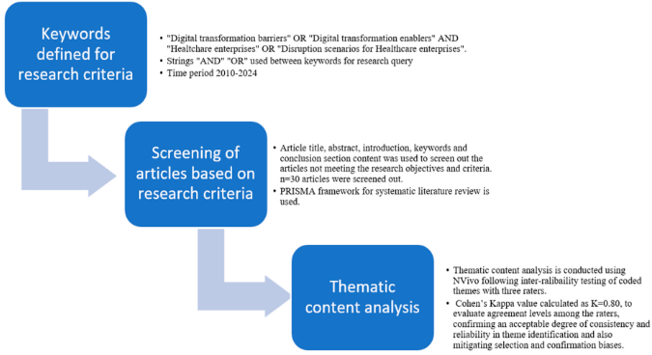
Figure 1. Structured literature review (SLR) methodology.
Thematic content analysis was based on an inductive approach where recurrent themes based on research objectives were identified and analyzed.

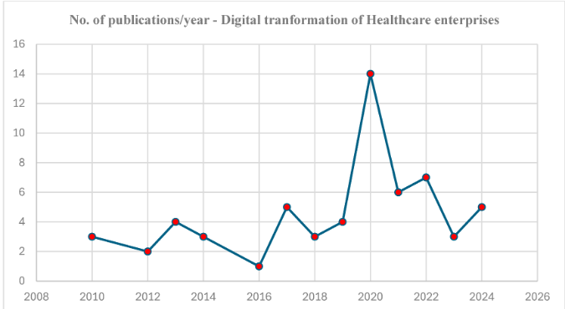

Figure 2. Peer-reviewed articles published on the digital transformation of healthcare enterprises, n = 60.

Figure 2, highlights the distribution of peer-reviewed articles published on the digital transformation of healthcare enterprises. Fourteen articles, the highest number of articles, were published during the COVID-19 pandemic disruption, 2020, and the second highest number (seven articles) during 2022, a year of another disruptive event, i.e., the Ukraine– Russia territorial war. This trend also highlights that interest in this topic is building up, with numbers increasing with future disruptive events.

- RESULTS AND DISCUSSION

Resistance to change and the human side of transformation is the most challenging as it relates to people’s needs for steadiness [29]. Resistance to adaptation for changes or new norms is a top barrier cited for moving towards digital transformation [29]. Employees refusing to change their traditional ways of working, which may be due to regulatory compliance, legacy of systems, or inadequate skills provides resistance to change [30]. Regulatory compliance is another key theme and is cited as a barrier where researchers have identified the insufficient development of the regulatory framework and standards as barriers to digital transformation of healthcare enterprises [31]. According to many research studies [32], there is a growing demand for data and tech-savvy executives with excellent analytical skills, and cloud-based business intelligence systems have made progress toward development in healthcare enterprises that utilize predictive and prescriptive analytics. Inadequate workforce skills and a low awareness level of employees in the use and management of emerging technologies, specifically AI/ML, is a significant factor and emergent theme for barriers to digital transformation of healthcare enterprises. Healthcare data are often stored in different formats across different systems, making it difficult to achieve seamless interoperability. Inconsistencies in terminology, coding systems (e.g., ICD-10 vs. SNOMED CT), and data-exchange protocols lead to errors and inefficiencies in patient care and analytics [33]. Without standardized data structures, integrating electronic health records (EHRs) across providers remains a challenge.

CONCLUSION

Emerging technologies, specifically digital twins (DTs), artificial intelligence (AI), and the Internet of Things (IoT) can be used to foster information technology (IT) and operational technology (OT) integration. Predictive analytics, capacity planning, workforce training, real-time patient monitoring, engagement, and cybersecurity threat mitigation are key use cases identified for digital transformation of healthcare enterprises. This is an important finding as it might help c-level and digital transformation executives to develop business cases for their digital transformation roadmap. Supply chain disruption, cybersecurity threats, and market volatility are the key themes identified for disruption scenarios. Emerging technologies like digital twins, AI, the IoT, and augmented reality can be used to mitigate the impact of disruption scenarios and this study will help to develop use cases and test cases. This study will also inform healthcare enterprises towards building resilient global supply chains and accelerating towards their digital transformation journey.
Effective change management, leadership as a change agent, collaboration between IT and OT, and workforce technology skills enablement are identified as the key themes for enablers of digital transformation. This finding is crucial for workforce training, change management, and sustaining digital transformation culture. Digital transformation leadership should possess collaborative, use-case driven, and evidence-based vision for digital transformation of their enterprises, as highlighted in this study.
Resistance to change, regulatory compliance, inadequate workforce skills, and poor collaboration between IT and OT are the key themes for barriers to digital transformation. This study might provide a starting point for healthcare enterprises to develop and define digital transformation goals. How to define digital transformation in the context of your enterprise and develop change initiatives are key questions which this research might help to explore. The findings from this study are qualitative and based on secondary research using structured literature review methodology, and need empirical evidence. The findings of this study are general for different types of healthcare enterprises and do not specifically explore variations in the factors of digital transformation with the size (small, medium, or larger) or type (medical device manufacturing, therapeutics, or patient care) of the enterprise. Future research work might help to validate the themes identified from this study with a survey and empirical evidence exploring variation in the factors for digital transformation among different types of healthcare enterprises. Developing the business case for digital transformation using the use cases mentioned in this study might help to test these cases and understand the potential tangible implications of implementing digital transformation initiatives. Capacity planning, patient care, and workforce training to mitigate potential risks during future disruption scenarios is another important implication of this study.
ACKNOWLEDGEMENTS
This review paper was made possible through the academic support and resources provided by [Your Institution or Department Name]. I extend my sincere thanks to my academic mentors and colleagues for their constructive feedback and encouragement throughout the writing process.
I also acknowledge the authors and researchers whose published works formed the foundation of this review. Their valuable contributions to the fields of healthcare, cybersecurity, and digital technologies greatly informed this study.
Finally, I appreciate the ongoing efforts of healthcare and cybersecurity professionals whose work continues to advance the safe and secure integration of digital technologies in healthcare systems.
.
REFERENCES

- Narula, S.; Kumar, A.; Prakash, S.; Dwivedy, M.; Puppala, H.; Talwar, V. Modeling and analysis of challenges for industry 4.0 implementation in medical device industry to post COVID-19 scenario. Int. J. Supply Oper. Manag. 2021, 10, 117–135.

- Gudergan, G.; Mugge, P. The gap between practice and theory of digital transformation. In Proceedings of the Hawaii International Conference of System Science, Hilton Waikoloa Village, HI, USA, 4–7 January 2017; pp. 1–15.

- Zhang, J.; Qi, L. Crisis preparedness of healthcare manufacturing firms during the COVID-19 outbreak: Digitalization and servitization. Int. J. Environ. Res. Public Health 2021, 18, 5456.

- Kraus, S.; Schiavone, F.; Pluzhnikova, A.; Invernizzi, A.C. Digital transformation in healthcare: Analyzing the current state-of-research. J. Bus. Res. 2021, 123, 557–567.

- Mariomontag. Why Are Digital Transformation Failure Rates so High? My Two Cents from Battle Field Scars, Mario Montag. 2024. Available

- Aguiar, T.; Gomes, S.B.; da Cunha, P.R.; da Silva, M.M. Digital transformation capability maturity model framework. In Proceedings of the 2019 IEEE 23rd International Enterprise Distributed Object Computing Conference (EDOC), Paris, France, 28–31 October 2019; IEEE: New York, NY, USA, 2019; pp. 51–57.

- Mauro, M.; Noto, G.; Prenestini, A.; Sarto, F. Digital transformation in healthcare: Assessing the role of digital technologies for managerial support processes. Technol. Forecast. Soc. Change 2024, 209, 123781.

- Brommeyer, M.; Whittaker, M.; Liang, Z. Organizational Factors Driving the Realization of Digital Health Transformation Benefits from Health Service Managers: A Qualitative Study. J. Healthc. Leadersh. 2024, 16, 455–472.

- Channi, H.K.; Shrivastava, P.; Chowdhary, C.L. Digital transformation in healthcare industry: A survey. In Next Generation Healthcare Informatics; Springer Nature: Singapore, 2022; pp. 279–293

- Kane, G.C.; Palmer, D.; Phillips, A.N. Achieving digital maturity. MIT Sloan Manag. Rev. 2017, 59

